

VISAP V2

Author: Bharathi ShivKumar
Reviewer: Madhukumar
Release/Version: Release/V2

Table of Contents

1.0 Scope 2
1.1 Purpose/Scope 3
1.2 Class Diagram 4
1.3 Nosql Components 4
1.4 DatHandlers 5
1.5 Class Structure 6
1.6 Logging and ExceptionHandling 7
1.6 Links to Refrence 8

Scope

Objective is to integrate the Application with database.
In the current sprint it has been integrated with mongo database.
Basically a nosql Collection,

Technology Stack

- Mongodb
- Vs 2010
- HTML5
- Log4net

Benefits of mongo db

- Schema less : MongoDB is document database in which one collection holds different different documents. Number of fields, content and size of the document can be differ from one document to another.

- Structure of a single object is clear

- No complex joins

- Deep query-ability. MongoDB supports dynamic queries on documents using a document-based query language that's nearly as powerful as SQL

- Tuning

- Ease of scale-out: MongoDB is easy to scale

- Conversion / mapping of application objects to database objects not needed

- Uses internal memory for storing the (windowed) working set, enabling faster access of data

- Intention is to make Application adaptable both for SQL and nosql databases.
For now we have used handlers for “GET” and posting the request to services. Going forward will be made REST driven.
Solution is designed to be extended for service driven.

Below is the Initial draft of Entities which will be refined in the upcoming sprints.
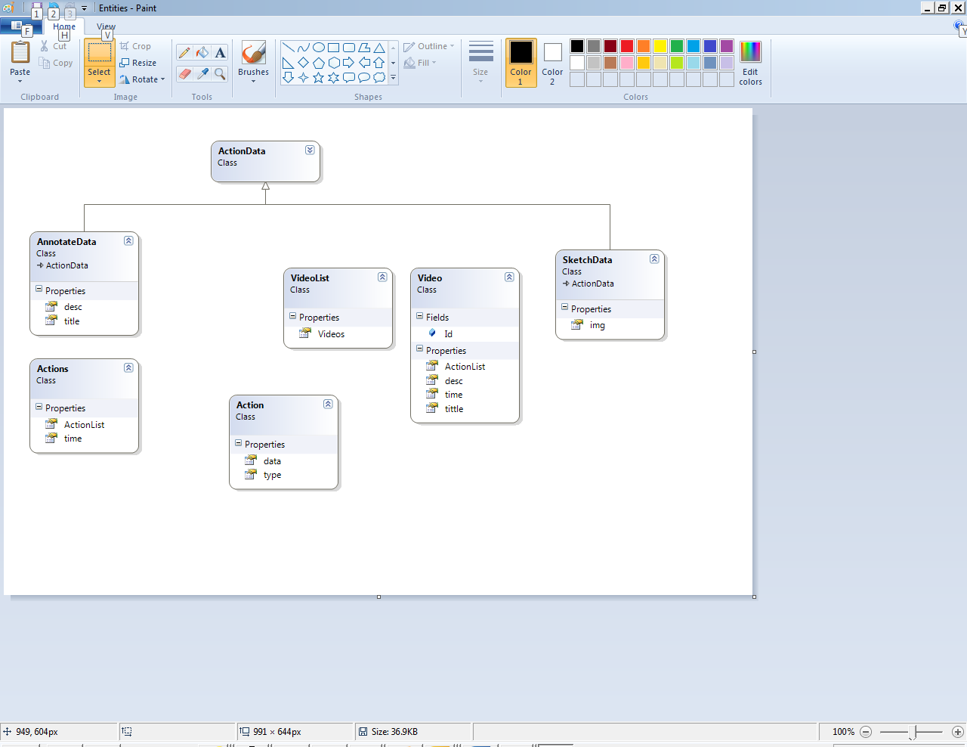

NOSQL Components:
We have added a service project which has independent classes for connecting to database, Which has entities and utilities too.
Drivers used for mongo collection are


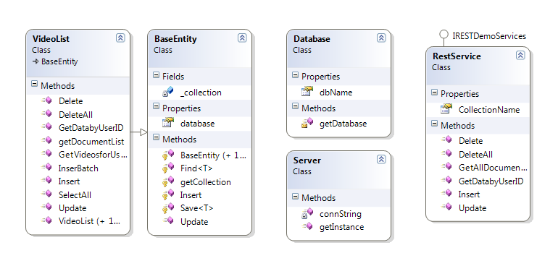
Client sends the request in json our querying of the collection is wrapped in services through datahandler.
Data Handlers:
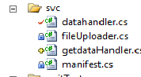

getdataHandlers has been used for getting the data from collections.similar to datahandler which the posted requests from client.

OVERAll Draft:

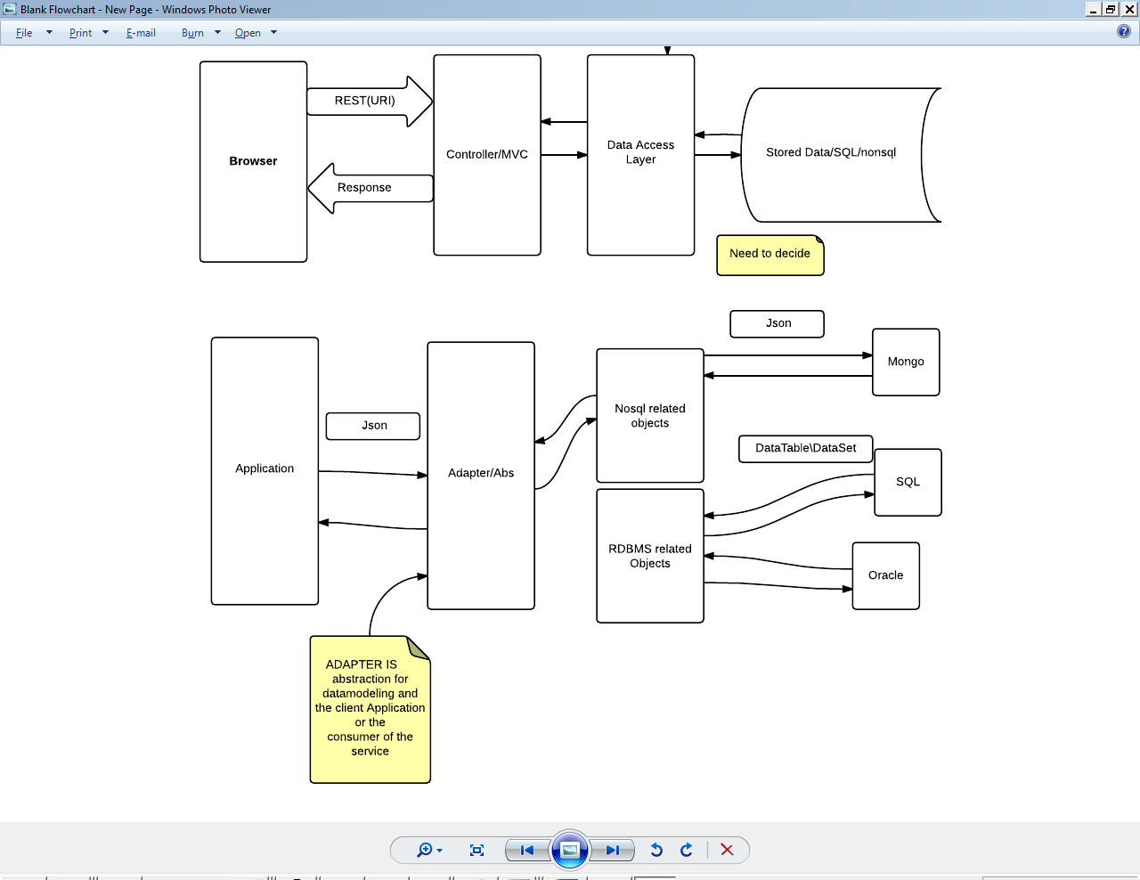

Initial Draft Including sql and nosql components:
Thoughts has been goiven to write a Adapter to route to sqkl and nosql related flows
Which will be calling by controller using the Routing.
Entities will means of communication ,it should able to support tplugging of the content.
OverAll Intial Class Structure:
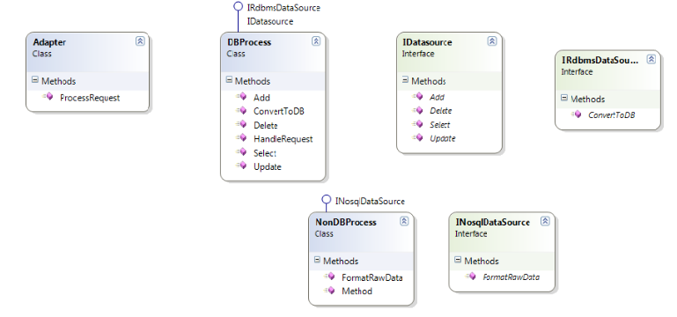
Logging and Exception Handling:
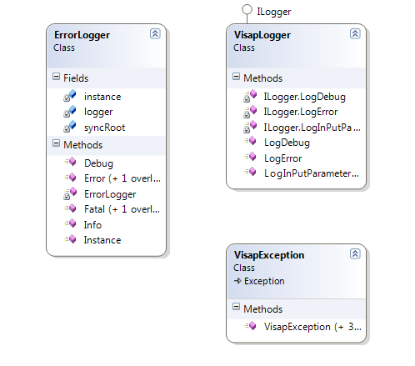
Logging we have use log4net which is a open source and configurable based on the levels
And the type of Errors or the information to be logged along with the desired path.Logging is configurable can be changed eventually if required.
Created Custom Exception class which will be thrown to the preceding layers .
Visaplogger is the application specific logger class which uses Errorlog object which is specific to log4net
Based on the requirement /Functionality provision has been given to taken a call on throwing the Original
Exception or an user friendly exception messages .

Links for reference:
http://www.mongodb.org/about/introduction/
http://www.tutorialspoint.com/mongodb/mongodb_update_document.htm

